Faye Van Roekel

December 12, 2019

WEB-420 Assignment 9.3

<https://vanroekel-api-gateway.herokuapp.com/>

/api/auth/register – Request

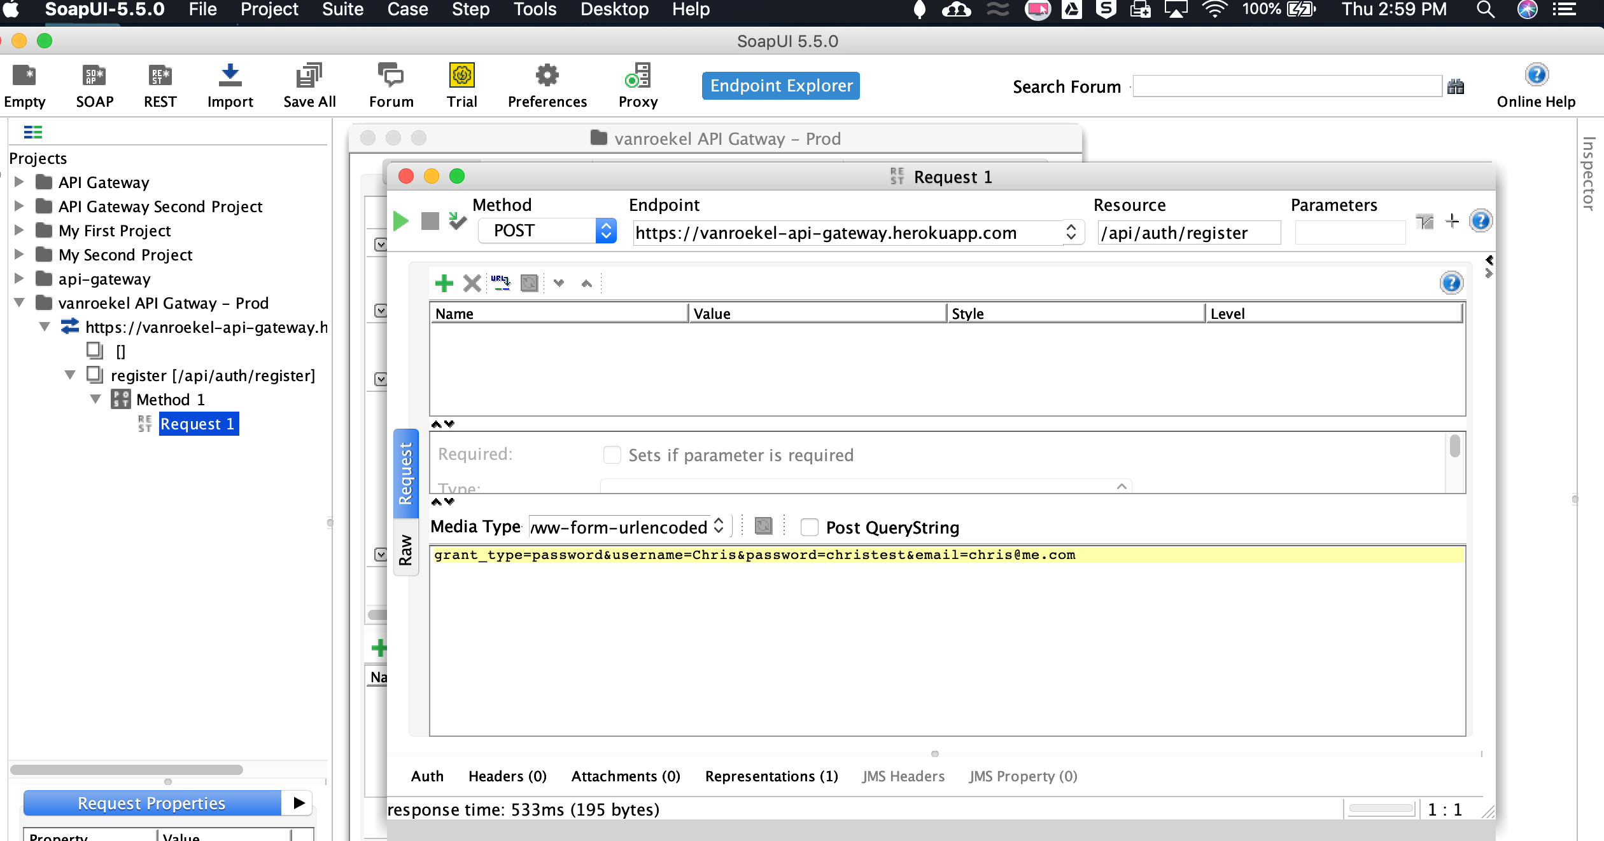

/api/auth/register – Response

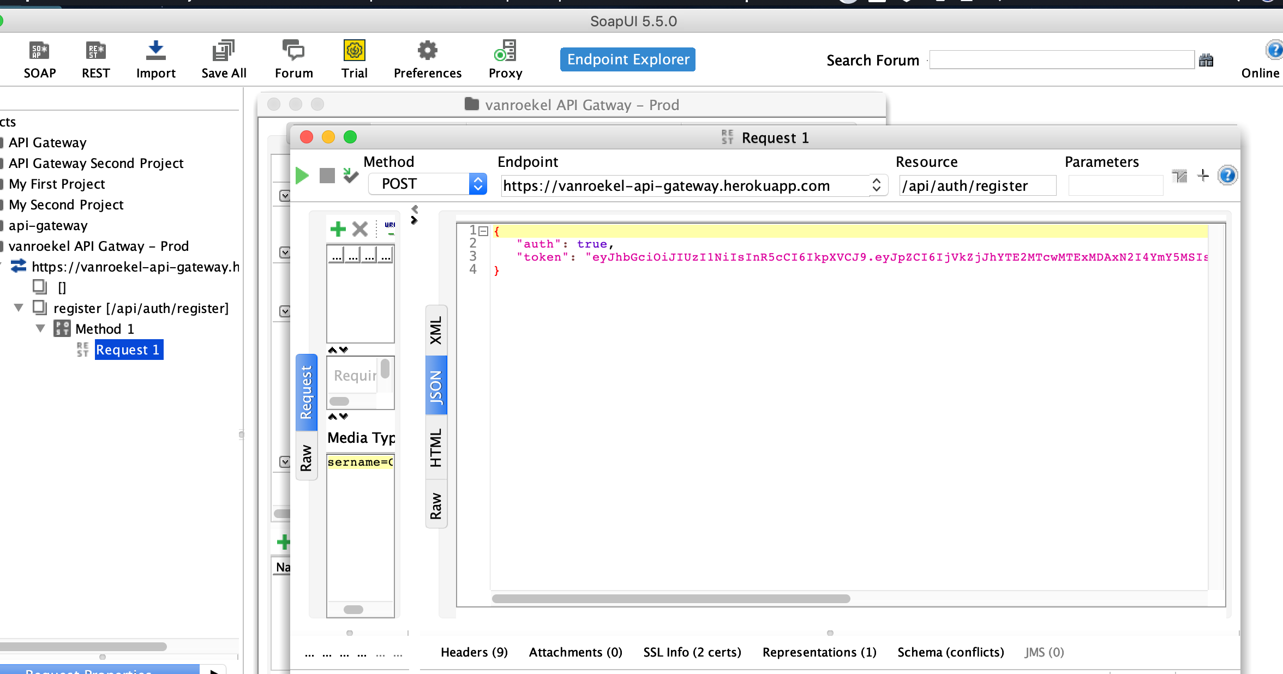

/api/auth/token – Request

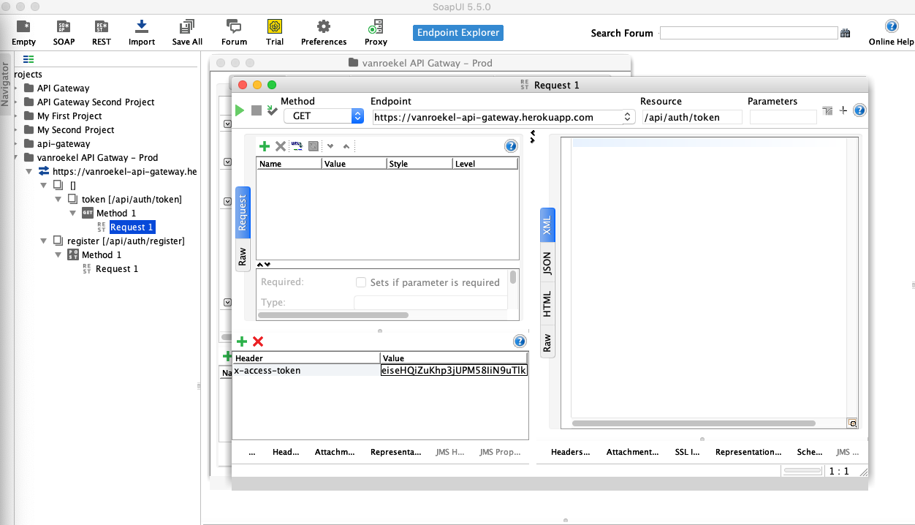

/api/auth/token – Response

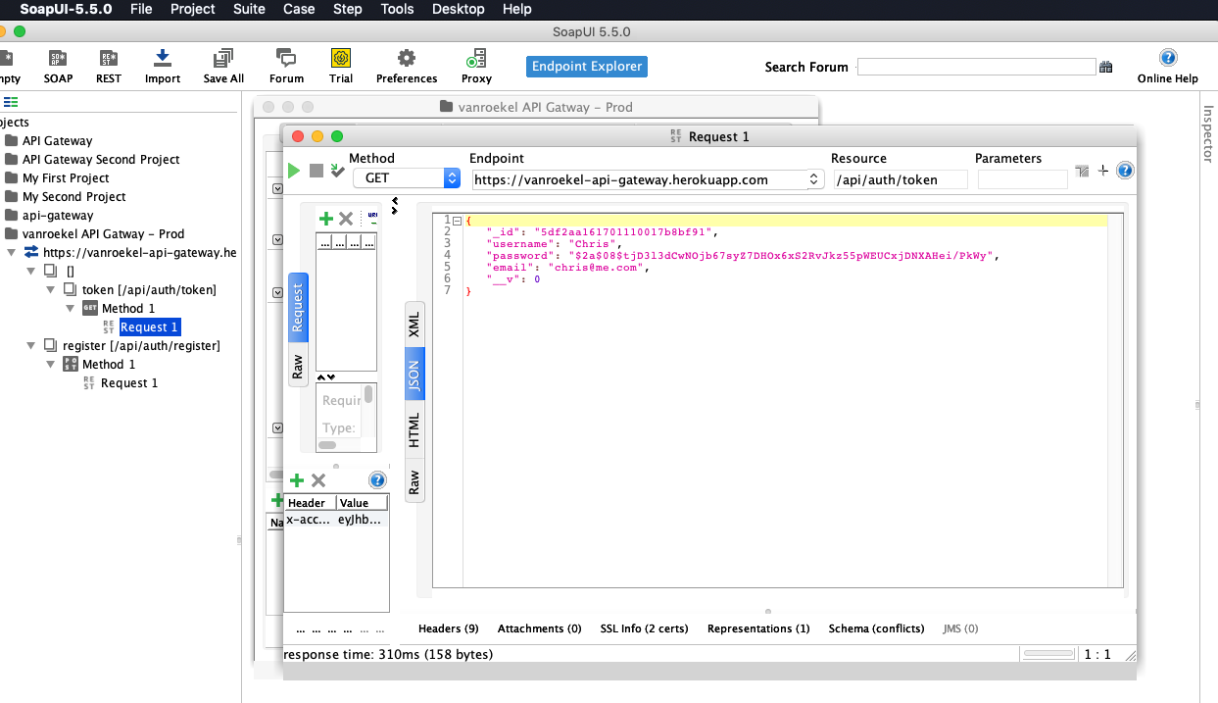

/api/auth/login – Request

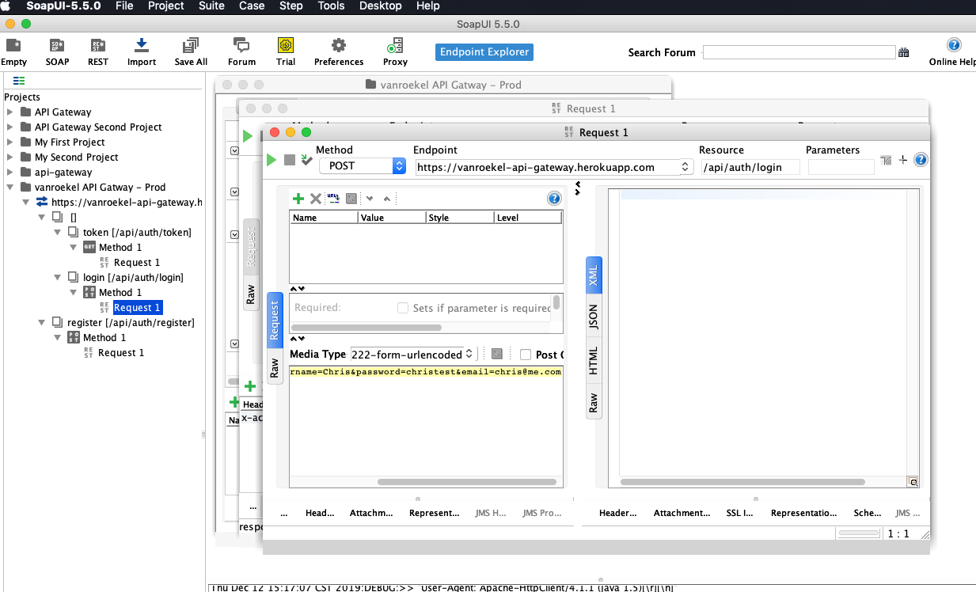

/api/auth/login – Response

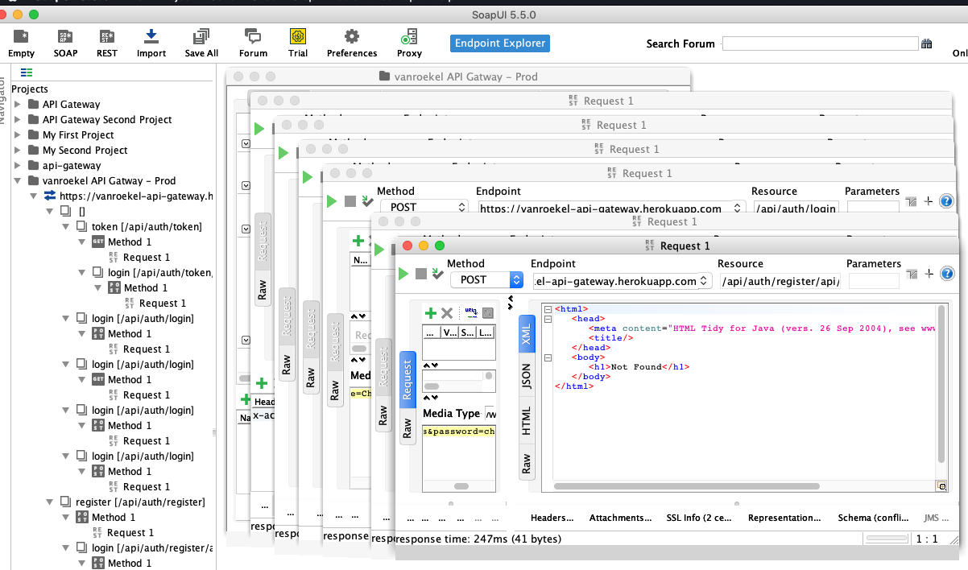

/api/auth/logout – Request

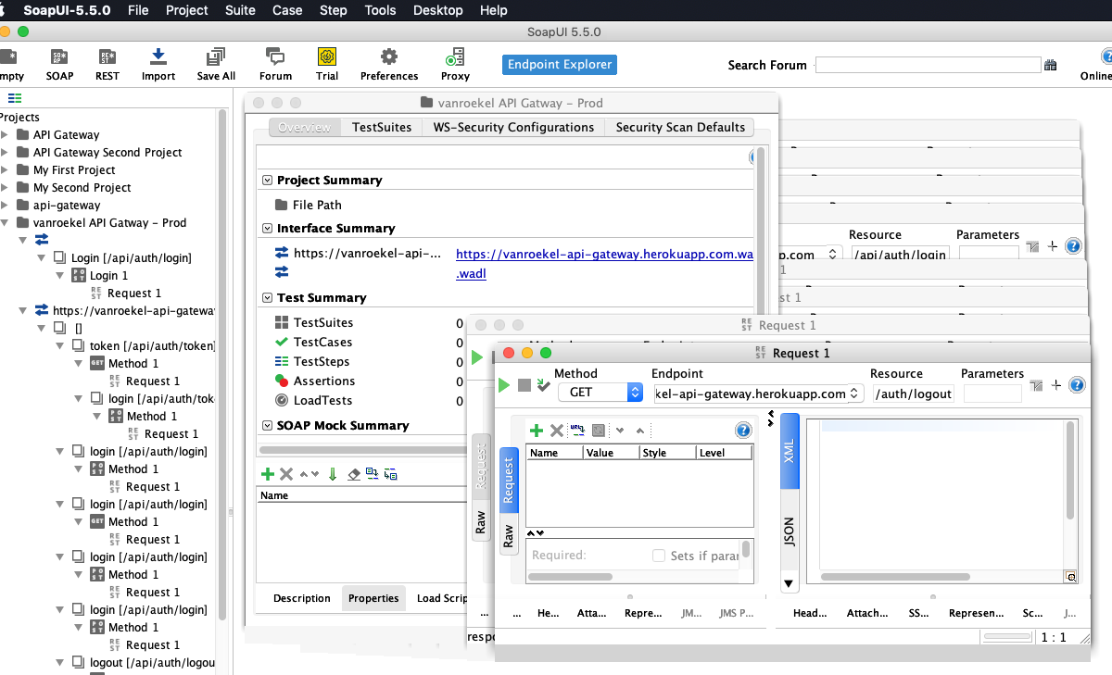

/api/auth/logout – Response

